CHAPTER -1

INTRODUCTION
1.1 About the Institutional Training
Institutional training is an important component of postgraduate education that enables students to gain practical knowledge and professional experience in a real working environment. It bridges the gap between theoretical concepts learned in the classroom and their practical application in business organizations. Through institutional training, students develop technical competencies, communication skills, problem-solving abilities, and professional ethics that are essential for their future careers.
As a part of the Master of Commerce with Computer Applications programme under Bharathiar University, I underwent institutional training at A S Pillai Techno Services, Tirupur, from 15 May 2026 to 08 June 2026. The training was carried out in the Human Resource Department, where I was exposed to various HR and administrative functions under the guidance of Mr. V. THAMARAI SELVAN, HR Manager.
During the internship, I actively participated in HR activities such as employee documentation, employee file organization, attendance record verification, employee data entry and updating, recruitment process observation, job description preparation, resume screening support, interview scheduling, candidate follow-up communication, employee onboarding support, document verification assistance, HR policy review, leave record maintenance, payroll data review, employee engagement activity support, email drafting and internal communication, training record maintenance, HR report preparation, and HR documentation and filing. These activities helped me understand the practical application of Human Resource Management principles in an environmental engineering organization.
The internship also enhanced my knowledge of office applications such as Microsoft Excel, Microsoft Word, Microsoft PowerPoint, and Outlook/Gmail, along with HR documentation systems and digital record management. It improved my communication skills, interpersonal relationships, time management, teamwork, and professional attitude. The practical exposure gained during the training strengthened my confidence in handling HR and administrative responsibilities in a professional environment.
Overall, the institutional training provided valuable learning opportunities and helped me understand the role of the Human Resource Department in supporting the workforce management and operational activities of the organization. The knowledge and experience gained during this training will serve as a strong foundation for my future career in Human Resource Management and business administration.

1.2 Objectives of the Institutional Training
The major objectives of the institutional training are as follows:
To gain practical knowledge of Human Resource Management in an environmental engineering organization. To understand the organizational structure and functioning of A S Pillai Techno Services. To study the recruitment, selection, induction, and employee management processes. To understand attendance, leave, payroll, and employee record maintenance procedures. To apply the theoretical knowledge gained through academic studies in a practical work environment. To improve communication skills, teamwork, workplace discipline, and professional ethics, thereby providing valuable practical experience and enhancing overall professional development.

CHAPTER -2

COMPANY PROFILE
2.1 About A S Pillai Techno Services
A S Pillai Techno Services is an environmental engineering company located in Tiruppur, Tamil Nadu. It provides water and wastewater treatment solutions for domestic and industrial clients. The company specializes in water treatment, wastewater treatment, RO, desalination, and Zero Liquid Discharge (ZLD) systems. It focuses on quality, modern technology, and reliable services. The company has various departments such as HR, Project Execution, Purchase, Finance and Accounts, Operations, and Administration. These departments work together to ensure smooth operations and customer satisfaction.
2.2 Vision
"To become a leading environmental engineering organization by providing innovative, sustainable, and cost-effective water and wastewater treatment solutions that contribute to environmental protection, resource conservation, and customer success."
2.3 Mission
The mission of A S Pillai Techno Services is:
- To provide high-quality environmental engineering solutions that meet customer requirements.
- To deliver efficient water and wastewater treatment systems through innovation and technical excellence.
- To promote sustainable water management and environmental conservation.
- To create a safe, healthy, and motivating work environment for employees.
- To continuously improve operational efficiency through technology and process optimization.
- To maintain long-term relationships with customers, employees, and stakeholders.
- To comply with environmental regulations and industry standards.
2.4 Objectives of the Company
The major objectives of A S Pillai Techno Services are:
- To provide reliable water and wastewater treatment solutions.
- To achieve customer satisfaction through quality service and timely delivery.
- To continuously improve operational efficiency and technical quality.
- To maintain effective Human Resource Management practices and support employee development.
- To comply with statutory regulations and environmental Standard while strengthening the company’s position in environmental engineering sector.

2.5 Organization Chart
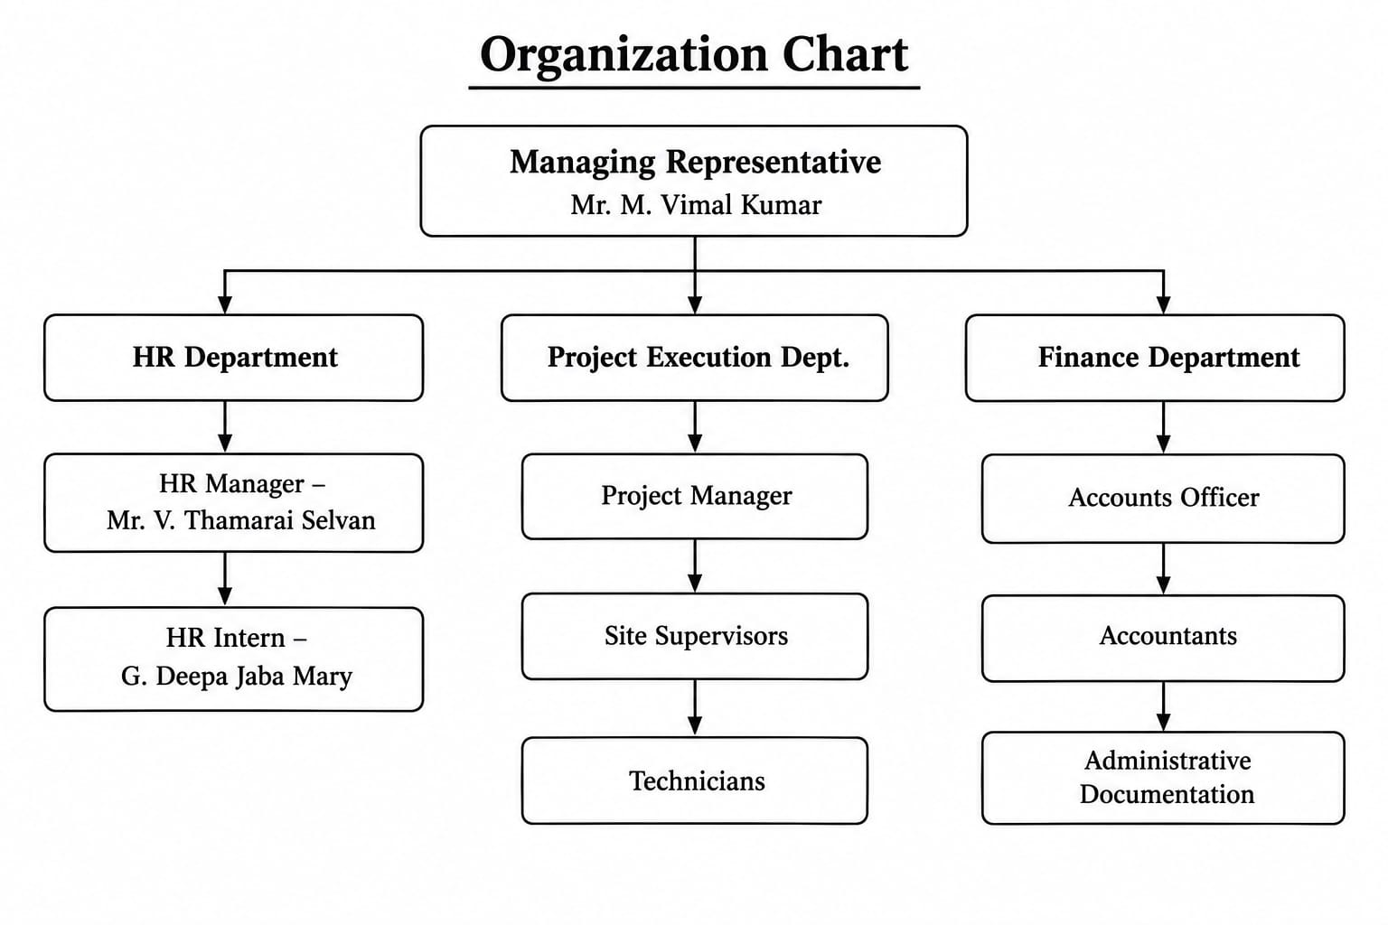

2.6 Infrastructure
The company has the necessary technical facilities and organizational systems that support smooth project execution and timely delivery of client requirements. Different departments work together to ensure quality and efficiency throughout every project.
The infrastructure includes:
- Project Execution and Site Coordination Office
- Water Quality and Process Monitoring Laboratory
- Procurement and Vendor Management Office
- Material and Equipment Stores
- Operations and Maintenance Support Unit
- Finance and Accounts Office
- Human Resource and Administration Office
- Client Coordination and Documentation Office
The use of modern equipment, systematic planning, and proper interdepartmental coordination helps the company maintain consistent service quality.
2.7 Services Offered
A S Pillai Techno Services provides comprehensive environmental engineering solutions according to the specific requirements of its industrial and domestic clients. The major services offered by the company include:
- Design and installation of water treatment plants.
- Wastewater and effluent treatment solutions.
- Reverse osmosis and desalination systems.
- Zero Liquid Discharge (ZLD) solutions.
- Operations and maintenance services for installed plants.
- Water quality testing and process monitoring.
- Technical support and troubleshooting services.
Through its reliable engineering services, the company aims to meet the quality expectations and changing requirements of its customers.

2.8 Market Supply
The company supplies its environmental engineering solutions to industrial clients in different parts of Tamil Nadu and across India. It designs and executes treatment systems based on client requirements and delivers the completed projects according to the technical, quality, and timeline requirements of each order. The company's commitment to quality, timely delivery, and customer satisfaction has helped it establish strong and long-lasting relationships with customers across the market. Through its efficient execution and reliable support system, the company continues to serve clients in various industrial sectors.
2.9 Human Resource Department
The Human Resource Department is one of the most significant departments of A S Pillai Techno Services because it manages the organization's human capital. Employees are the most valuable asset of any engineering services organization, and effective Human Resource Management ensures that the right employees are recruited, trained, motivated, and retained. The department is responsible for planning manpower requirements, recruiting suitable candidates, maintaining employee records, monitoring attendance, coordinating payroll, organizing employee welfare activities, and ensuring compliance with labour laws. It also promotes a positive work environment by encouraging teamwork, effective communication, and employee engagement.
Functions of the Human Resource Department:
- Recruitment and Selection
- Employee Induction and Onboarding
- Attendance Management
- Leave Administration
- Employee Record Maintenance
- Payroll Coordination
- Employee Welfare
- Training Coordination
- HR Documentation and Reporting
- Statutory Compliance
- Employee Communication and Engagement

2.10 Project Execution Department
The Project Execution Department is the core functional unit of A S Pillai Techno Services. It is responsible for planning, implementing, and completing environmental engineering projects such as effluent treatment plants, sewage treatment plants, reverse osmosis systems, and Zero Liquid Discharge systems while maintaining the required standards of quality, efficiency, and productivity. The department plans and monitors every stage of execution, from site assessment to final commissioning of treatment systems, in close coordination with other departments to achieve project targets within the scheduled time.
Functions of the Project Execution Department:
- Planning project schedules.
- Allocation of manpower to project sites.
- Monitoring project progress.
- Coordinating with the Water Quality Department.
- Reducing resource wastage.
- Maintaining project records.
- Ensuring timely completion of client projects.
- Monitoring equipment utilization and productivity.
2.11 Water Quality and Process Monitoring Department
Quality is one of the key factors determining customer satisfaction and organizational reputation. The Water Quality and Process Monitoring Department ensures that every treatment system installed by the company meets the required performance specifications before handover to clients. Water testing and process monitoring are carried out at different stages of a project to identify and rectify performance issues at the earliest possible stage.
Functions of the Water Quality and Process Monitoring Department:
- Testing water and effluent samples.
- Monitoring process performance.
- Conducting laboratory analysis.
- Verifying compliance with standards.
- Optimizing treatment processes.
- Preparing quality inspection reports.
- Approving systems before handover.
- Supporting customers on performance issues.
2.12 Purchase Department
The Purchase Department is responsible for procuring materials, equipment, machinery, chemicals, and other resources required for the smooth functioning of the organization. The department ensures that quality materials are purchased at competitive prices while maintaining uninterrupted project execution.
Functions of the Purchase Department:
- Identifying material requirements.
- Requesting quotations.
- Supplier evaluation.
- Purchase order preparation.
- Material procurement.
- Delivery follow-up.
- Vendor relationship management.
- Maintaining procurement records.
2.13 Material and Equipment Management Department
The Material and Equipment Management Department manages the receipt, storage, and issue of materials, spare parts, and equipment used in project activities. Efficient inventory management helps reduce wastage, avoid shortages, and maintain smooth project execution.
Functions of the Material and Equipment Management Department:
- Receiving materials and equipment.
- Material inspection.
- Inventory recording.
- Safe storage.
- Issuing materials to project teams.
- Stock verification.
- Inventory reporting.
- Maintaining stock registers.
2.14 Finance and Accounts Department
The Finance and Accounts Department manages the financial activities of A S Pillai Techno Services. It maintains financial records, prepares reports, controls expenses, and ensures compliance with statutory regulations. The HR Department coordinates with Accounts during salary preparation by providing attendance and leave information.
Functions of the Finance and Accounts Department:
- Recording financial transactions.
- Salary processing.
- Budget preparation.
- Cost control.
- Tax compliance.
- Financial reporting.
- Payment processing.
- Bank reconciliation.
2.15 Operations and Maintenance Department
After a treatment system is commissioned, it is handed over to the Operations and Maintenance Department for ongoing support. This department ensures that installed treatment plants operate efficiently through preventive maintenance, troubleshooting, and performance monitoring.
Functions of the Operations and Maintenance Department:
- Plant operation monitoring.
- Equipment maintenance.
- Preventive maintenance planning.
- Troubleshooting technical issues.
- Performance evaluation.
- Customer support services.
- Operational reporting.
- Maintenance documentation.

2.16 Client Coordination Department
As A S Pillai Techno Services serves industrial clients across regions, the Client Coordination Department manages communication and service delivery throughout the project lifecycle. This department ensures customer satisfaction while complying with service commitments.
Functions of the Client Coordination Department:
- Client communication.
- Requirement gathering.
- Project update coordination.
- Complaint handling.
- Documentation support.
- Feedback collection.
- Service scheduling.
- Relationship management.

CHAPTER -3

INSTITUTIONAL TRAINING ACTIVITIES
3.1 Day 1 to 21 Work Learned
Day 1 - Company Orientation & HR Department Introduction:
The company orientation provided a clear understanding of the organizational structure, different functional areas and the overall working process of the organization. It also helped me understand the roles and responsibilities of the Human Resource Department and how various activities are coordinated within the company.
Day 2 - Daily Schedule Preparation:
Daily schedule preparation helped me develop time management and task planning skills. I also gained practical exposure to organizing daily HR activities in a systematic manner and understood the importance of careful planning.
Day 3 - Employee File Organization:
Employee file organization gave me an understanding of how personnel records are maintained systematically. It improved my ability to organize employee information and helped me learn employee record maintenance procedures.
Day 4 - Attendance Record Verification:
Attendance record verification provided practical knowledge of the attendance tracking process followed in the organization. It helped me understand how attendance information is checked carefully before being forwarded for payroll processing.
Day 5 - Employee Data Entry & Updating:
Employee data entry and updating provided an understanding of the importance of data accuracy and record management. This activity improved my familiarity with maintaining employee information in an organized manner using MS Excel.
Day 6 - Recruitment Process Observation:
Observing the recruitment process gave me a better understanding of how candidates are identified, screened, and selected. This activity helped me learn the recruitment workflow followed by the organization.
Day 7 - Job Description Preparation:
Job description preparation provided practical knowledge about how job roles and requirements are defined. It helped me understand the importance of clearly specifying qualifications, skills, and responsibilities for each position.
Day 8 - Resume Screening Support:
Resume screening support provided an understanding of the candidate shortlisting process. It helped me gain knowledge about evaluating resumes against job requirements and maintaining recruitment records carefully.
Day 9 - Interview Scheduling:
Interview scheduling provided an understanding of how interviews are planned and coordinated with candidates and panel members. It also helped me develop interview coordination and communication skills using Outlook/Gmail.
Day 10 - Candidate Follow-up Communication:
Candidate follow-up communication provided practical exposure to professional business communication. It improved my ability to communicate clearly and politely with candidates regarding their application status.
Day 11 - Employee Onboarding Support:
Employee onboarding support provided an understanding of the joining process and documentation required for newly appointed employees. It helped me learn how identity proofs, educational certificates, bank details, and other joining formalities are organized.
Day 12 - Document Verification Assistance:
Document verification assistance provided practical knowledge of verification and compliance procedures. This activity improved my attention to detail while checking employee documents.
Day 13 - HR Policy Review:
HR policy review provided an understanding of the company policies and regulations followed within the organization. It helped me become familiar with the systematic handling of policy-related documents.
Day 14 - Leave Record Maintenance:
Leave record maintenance provided an understanding of the leave management process followed in the organization. It helped me gain practical knowledge of updating leave records and organizing leave-related documentation.
Day 15 - Payroll Data Review:
Payroll data review provided an understanding of basic business payroll concepts. It helped me learn how attendance and leave information is used in salary preparation and improved my accuracy in handling payroll-related data.
Day 16 - Employee Engagement Activity Support:
Employee engagement activity support provided an understanding of the importance of employee engagement in the organization. It helped me learn how engagement activities contribute to employee motivation and a positive work environment.
Day 17 - Email Drafting and Internal Communication:
Email drafting and internal communication improved my business communication skills. It helped me understand the importance of clear, professional, and timely communication within the organization.
Day 18 - Training Record Maintenance:
Training record maintenance provided an understanding of the employee development process. It helped me learn how training-related information is recorded and maintained for employee growth and development.
Day 19 - HR Report Preparation:
HR report preparation helped me develop better skills in organizing HR information into clear and structured reports. It also improved my understanding of HR reporting and analysis using MS Excel.
Day 20 - HR Documentation and Filing:
HR documentation and filing improved my documentation management skills. I understood the importance of proper filing, confidentiality, and easy retrieval of employee records when required.

Day 21 - Internship Report Preparation & Submission:
The internship report preparation and submission activity helped me understand how the knowledge and experience gained during the internship can be organized into a professional report. It also improved my ability to present the overall HR functions and practical exposure gained in a clear and structured manner.

CHAPTER -4

LEARNING OUTCOMES
4.1 Technical Skills Learned
During my training, I gained practical exposure to various HR documents, software, and office tools used in routine Human Resource activities. The software and tools used during the internship included Microsoft Word, Microsoft Excel, Microsoft PowerPoint, Outlook/Gmail, PDF Reader, HR documentation registers, employee attendance registers, biometric attendance system, and other HR-related documents. Through practical involvement in these activities, I developed a better understanding of maintaining employee records, preparing and verifying HR documents, recording attendance and leave information, supporting recruitment activities, and handling office documentation efficiently.
4.2 Personal Skills Developed
The institutional training at A S Pillai Techno Services helped me improve my practical and professional skills. During the training, I developed HR documentation and record maintenance skills and gained practical knowledge in organizing personnel files, verifying attendance records, supporting recruitment and onboarding activities, and handling various HR documents. I also improved my documentation, data entry, and Microsoft Excel skills through practical exposure to routine office activities. The training helped me develop attention to detail, time management, communication, teamwork, and organizational skills. In addition, I improved my professional discipline, confidentiality management, and problem-solving abilities by handling real-time tasks and understanding the importance of accuracy, responsibility, and efficiency in the workplace.

CHAPTER -5

CONCLUSION
My institutional training at A S Pillai Techno Services was a valuable and enriching learning experience. During the training period, I gained practical exposure to various activities related to the Human Resource Department, including employee documentation, employee file organization, attendance record verification, recruitment support, interview scheduling, employee onboarding, leave record maintenance, payroll data review, training record maintenance, HR report preparation, and HR documentation and filing.
The training helped me understand the importance of accuracy, proper documentation, confidentiality, and systematic record maintenance in HR operations. I also gained a better understanding of how the Human Resource Department coordinates with other departments to support the smooth functioning of the organization.
The practical experience gained during the training enabled me to connect my academic knowledge of Commerce and Human Resource Management with real-world organizational practices. It also helped me improve my skills in documentation, data handling, communication, teamwork, time management, and professional discipline.
Overall, my institutional training at A S Pillai Techno Services provided me with valuable practical knowledge and enhanced my confidence in handling HR-related responsibilities. The experience has strengthened my understanding of Human Resource Management practices and will serve as a useful foundation for my future career in the HR and Administration field.

ANNEXURE

